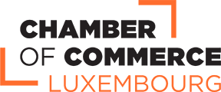

Luxembourg Digital ICT WEEK
13 – 17 September 2021
Working programme

13 September
13.30 – 14.30 | Presentation of the Luxembourg’s Startup ecosystem – INSIDE Startup Luxembourg (tbc)
14.30 – 17.30 | Networking with Incubators & International Business Meetings by b2fair
14 September
10.00 – 18.00 | ICT SPRING (https://www.ictspring.com/programme/the-programme/)  Digital Summit / Digital supply chain summit  Fintech Summit  Space Forum
13.00 – 17.30 | International Business Meetings by b2fair
15 September
10.00 – 18.00 | ICT SPRING (https://www.ictspring.com/programme/the-programme/)  European Security Forum  Mastermind Summit
13.00 – 17.30 | International Business Meetings by b2fair
17 – 18 September
11.00 – 12.00 | Virtual company visit I
13.00 – 17.30 | International Business Meetings by b2fair
3rd December
11.00 – 12.00 | Virtual company visit II
13.00 – 17.30 | International Business Meetings by b2fair

